Luca Dai

COMP 5660 Fall2021

9/12/2021

**Assignment 1b Report and Statistical Analysis**

**Introduction**:

The purpose of this assignment is to compare the functionality of PacMan map generating between the random search algorithm with the combination of standard Evolutionary Algorithm. The author using the green1b_config.txt as the config file running 2000 evaluation for 30 turns. This test applying k-Tournament-with-Replacement as parent selection method, 1-Point-Crossover as recombination method, Truncation as survival selection method (In tournament with replacement, the variable k set to five). The other method also been created in this assignment.

**Method description:**

parent selection method:

Using:

k Tournament with Replacement: Select k individual from population, compare fitness between k individuals, save the individual with highest fitness in parent population, then select the next tournament until the parent population is full.

Other method author has written:

Uniform Random Selection: Randomly select n parents from population.

Fitness Proportionate Selection

Recombination method:

Using:

1 Point-Crossover: Randomly select one point, then cut both parents at that point, then reform a child from parents’ segments.

Other method author has written:

Uniform Recombination: Randomly choose one parent, copy one digit to child, then do it again, until child has same length with parent.

Survival method:

Using:

Truncation: select the child with best fitness in population until survival list is full.

Other method author has written:

k Tournament without Replacement

**Statistical Analysis:**

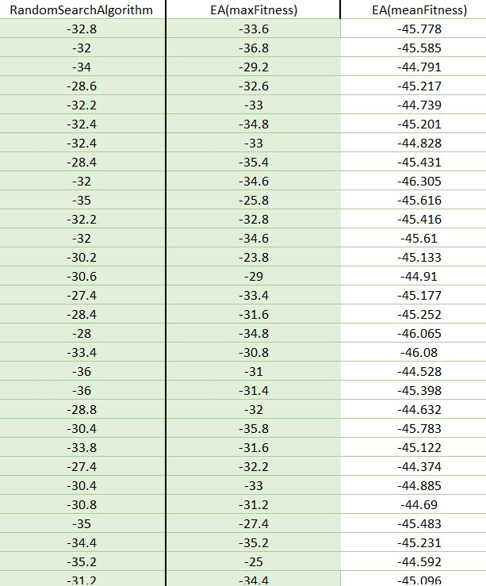

Table – Max Fitness List of 30 runs

Random Search Algorithm randomly generated the binary map just like flip coin, then keep track of the individual with best fitness and return it. As table 1 showing, the 24th turn has a -27.4 as the highest fitness in the Random Search Algorithm. On the other hand, the author’s EA applying k-Tournament-with-Replacement, 1-Point-Crossover, Truncation methods has the best max fitness -23.8.

Statistical Hypothesis Test

Since both algorithms have 30 turns, it will follow the F test in the first stage. Alpha is 0.05.

|  |  |  |
| --- | --- | --- |
| F-Test Two-Sample for Variances | | |
|  |  |  |
|  | *Variable 1* | *Variable 2* |
| Mean | -31.7133 | -31.9933 |
| Variance | 6.628092 | 10.31857 |
| Observations | 30 | 30 |
| df | 29 | 29 |
| F | 0.642346 |  |
| P(F<=f) one-tail | 0.119626 |  |
| F Critical one-tail | 0.475965 |  |

Since P(F<=f) one-tail = 0.119626 which is less than 1 and less than the critical value 0.476, the difference between the means for the two samples is significantly different. The test has rejected the null hypothesis of equal variance. Two variances are assumed to be unequal. Two-tailed two-sample t-test assuming unequal variances should run in the next step. Alpha is 0.05.

|  |  |  |
| --- | --- | --- |
| t-Test: Two-Sample Assuming Unequal Variances | | |
|  |  |  |
|  | *Variable 1* | *Variable 2* |
| Mean | -31.7133 | -31.9933 |
| Variance | 6.628092 | 10.31857 |
| Observations | 30 | 30 |
| Hypothesized Mean Difference | 0 |  |
| df | 55 |  |
| t Stat | 0.372543 |  |
| P(T<=t) one-tail | 0.35546 |  |
| t Critical one-tail | 2.004045 |  |
| P(T<=t) two-tail | 0.71092 |  |
| t Critical two-tail | 2.304426 |  |

Since P(T<=t) two-tail = 0.71092 which is less than 1 but less than the critical value 0.2.304, the difference between the means for the two samples is not significantly different. The test has accepted the null hypothesis of equal variance. Two variances are assumed to be equal. In Conclusion, two algorithms do not have significant differences.

**Conclusion**:

Relate to the EA means fitness on Table 1, the mean value stopped closed to 45, which means population in EA, has a fitness range from the best fitness -23 to about -70.

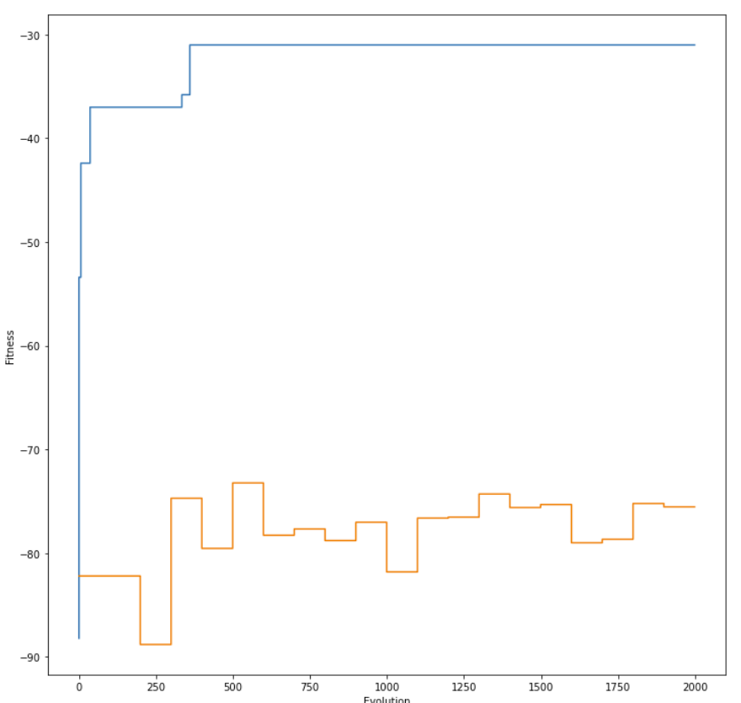

Table – author’s EA best fitness stairstep plot

As the stairstep plot of best fitness’s EA performance shows in table-2, the best fitness converged when the evaluation only approached 500, and it did not improve after 500. Author’s algorithm did not improve very much from the Random Search Algorithm. There’s more change need to adjust in author’s algorithm, like increase the k or change some combination between different algorithm.